**Use Case: Setting up Transit Gateway and VPC Endpoints for a Multi-VPC Architecture**

**Scenario:**

**A large organization is migrating its on-premises infrastructure to the AWS cloud.**

**The organization's architecture involves multiple VPCs for different departments and applications, each requiring secure communication with centralized services and external resources.**

**The IT team needs to design and implement a scalable and efficient network architecture to accommodate the organization's growth and ensure robust connectivity between VPCs and external services.**

1. **Design and deploy a scalable network architecture using AWS Transit Gateway to simplify network connectivity between multiple VPCs.**

**Step 1: Plan Your IP Addressing**

**non-overlapping CIDRs from different classes:**

**1.)VPC-A (N. Virginia, us-east-1) → 10.0.0.0/16**

**2.) VPC-B (OHIO -us-east-2) → 172.16.0.0/16**

**3). VPC-C (California, us-west-1) → 192.168.0.0/16**

**4.)VPC-D (Oregon, us-west-2) → 100.64.0.0/16**

**Step 2: Create 4 VPCs (Non-default)**

**Create VPCs (in 4 different regions)**

**Go to VPC Console → Your VPCs → Create VPC.**

**Create 1 private subnets in each VPC (in different AZs).**

**No public subnets needed (since no IGW/NAT).**

**Attach IGW TO only oneVPC to**  (**VPC-A (N. Virginia, us-east-1) → 10.0.0.0/16**)

**Create a Route Table for each set of subnets and associate them.**

**✅ Repeat for all 4 regions.**

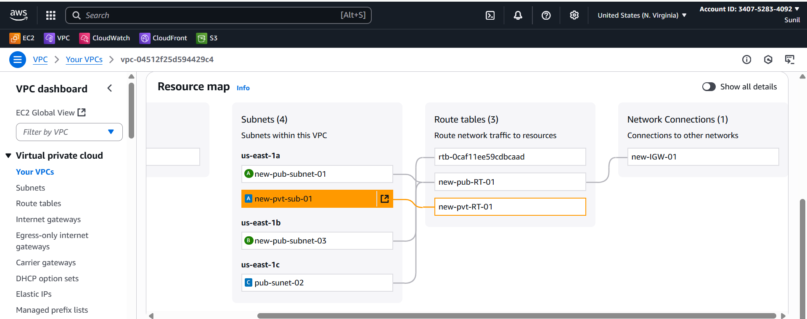

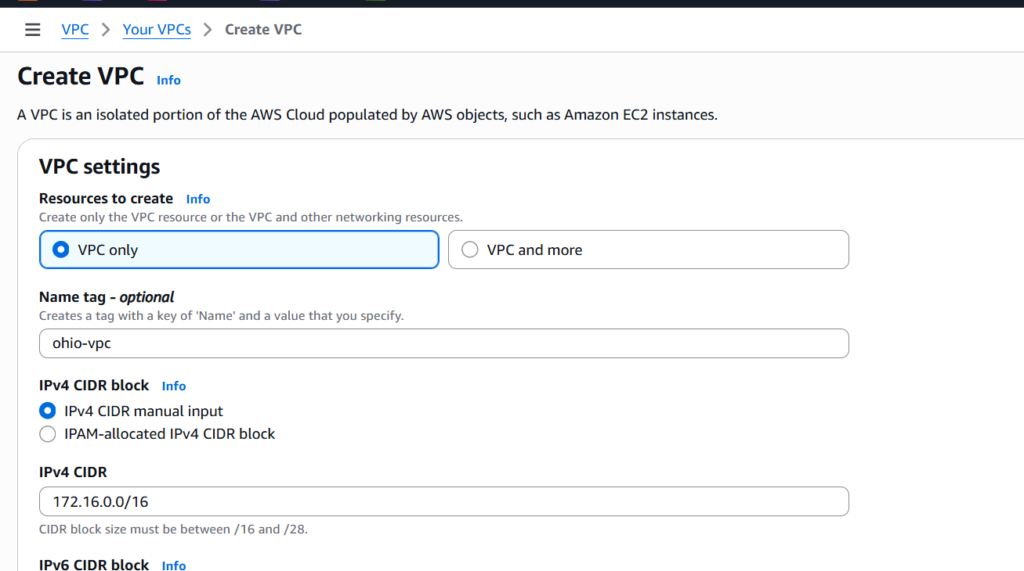

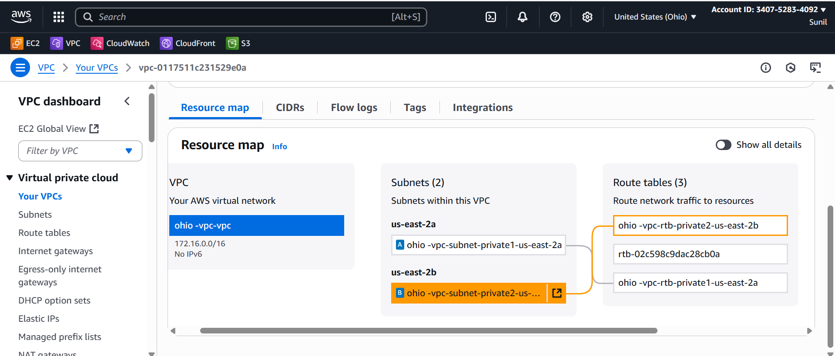

Now Simlarly create Vpcs subnets and RouteTables in other vpc2,vpc3 and vpc4  
i.e in 4 different regions

**Step 3: Create Transit Gateways**

## Create Transit Gateways (1 per region)

Repeat per region.

1. **VPC Console → Transit Gateways → Create transit gateway**

Attach each VPC to its regional TGW

**TGW VPC attachment** with the **private subnets**.

**Associate** the attachment with the TGW route table in that region.

**Enable route propagation** from that attachment into the TGW route table (or add static routes).

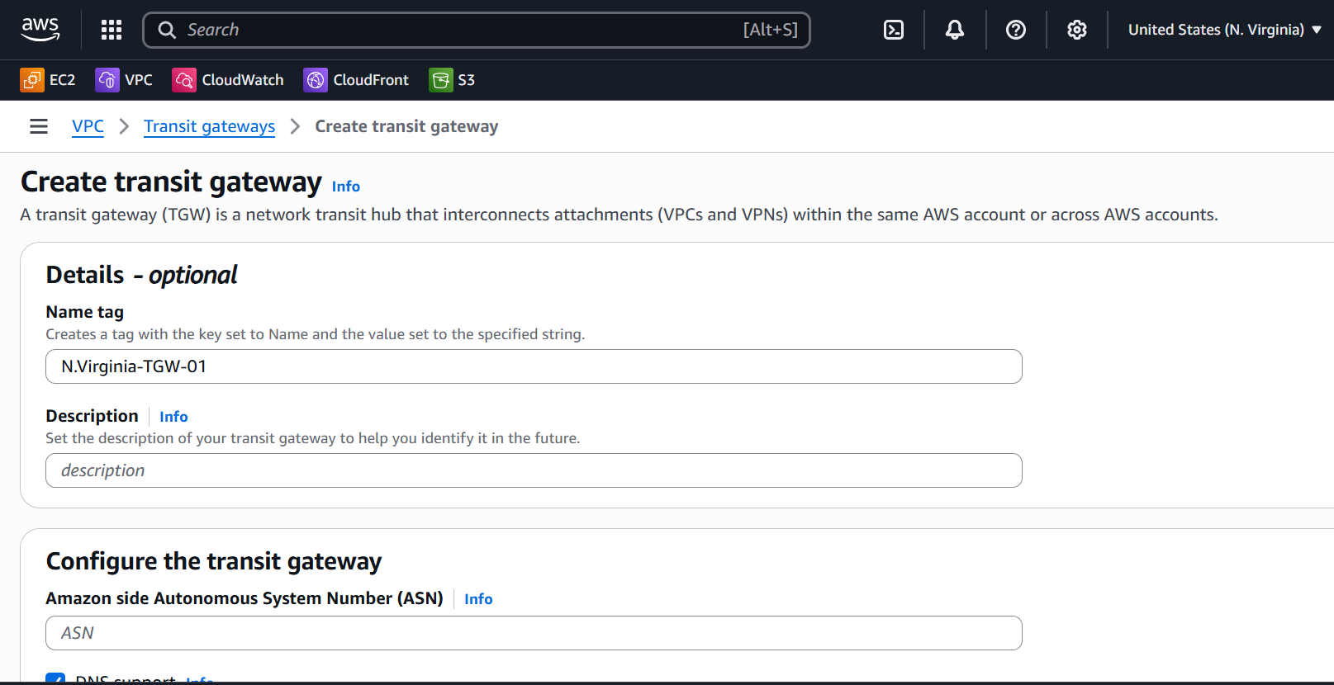

## Step-4 Attach Each VPC to its Regional TGW

Repeat per region.

1. **Transit Gateway Attachments → Create**

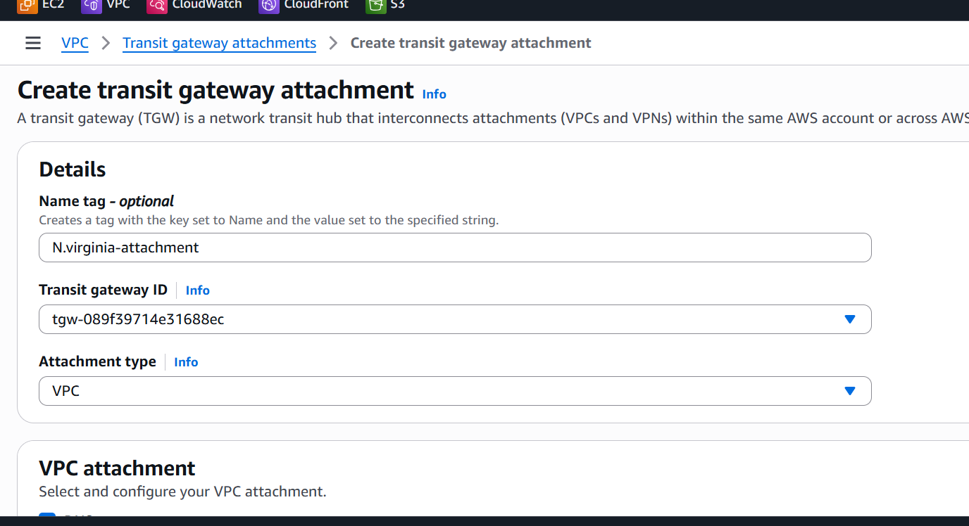

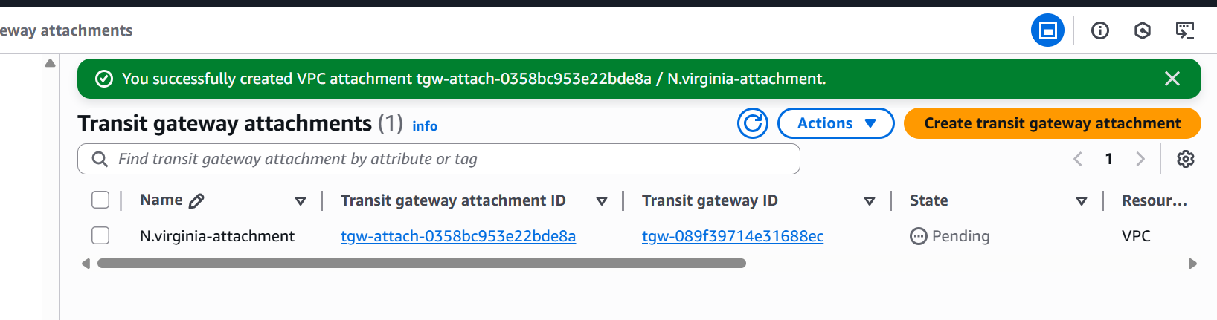Now create Transit Gateway in vpc2,vpc3 and vpc4  
 in 4 different regions and attach with the Attach Each VPC to its Regional TGW

**STEP-5:**

## Establish Inter‑Region TGW Peering (Hub‑and‑Spoke)

### Create Peering Attachment (Requester Side)

1. In the **AWS Console**, go to the **VPC Dashboard** in **Region A** (e.g., us-east-1).
2. On the left menu, choose **Transit Gateway Attachments → Create transit gateway attachment**.
3. Select:
   * **Attachment type** → Peering connection.
   * **Transit Gateway ID** → TGW-US-E1.-Virginia
   * **Region** → target region (e.g., us-west-2 ohio).
   * **Transit Gateway ID** of the peer (TGW-of-Ohio)

Click **Create transit gateway attachment**.

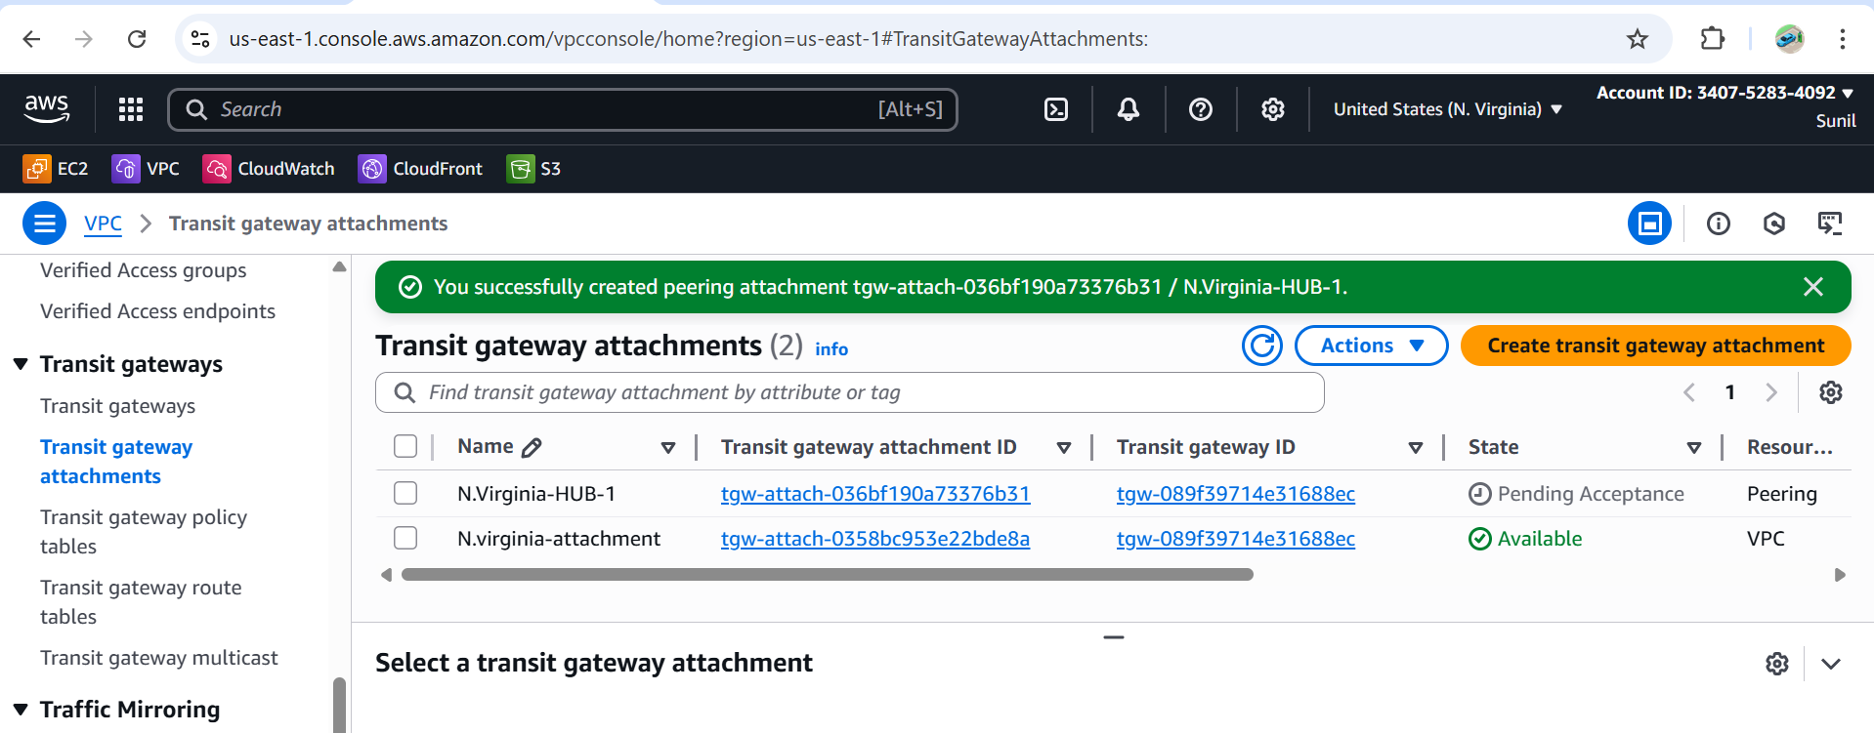

### .Accept Peering Attachment (Accepter Side)

1. **Switch to the peer region’s console (e.g.,Ohio-region).**
2. **Go to Transit Gateway Attachments.**
3. **You’ll see a pending peering request.**
4. **Select it → Actions → Accept.**

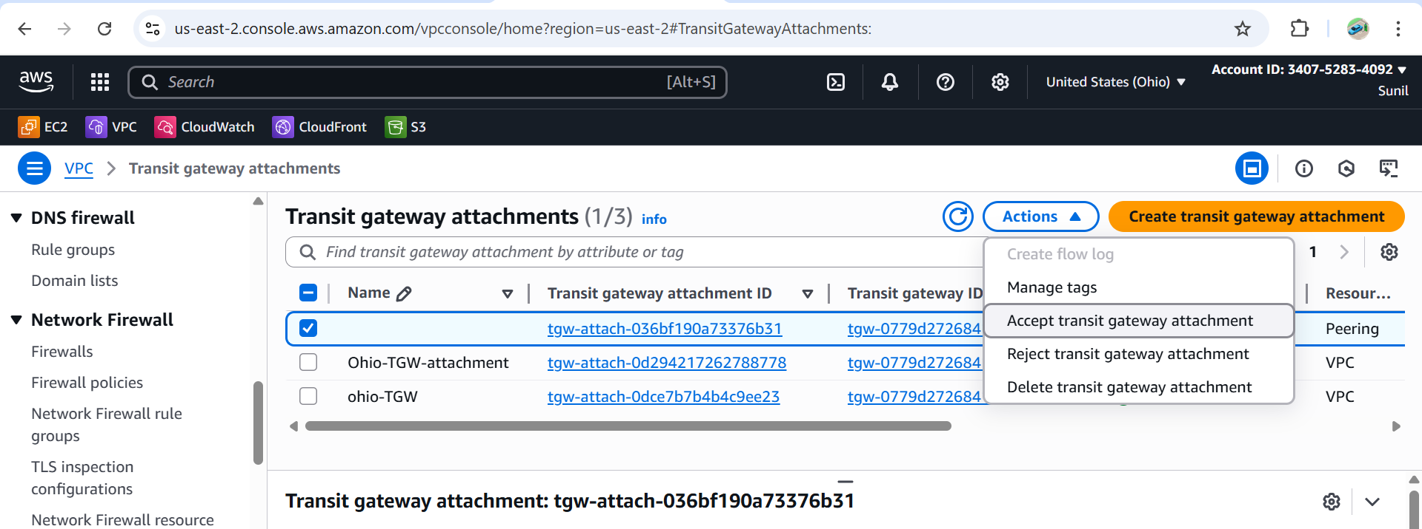

* Similarly configure with the vpc3 and vpc4 and
* also configure the same with all the Regions with one to all

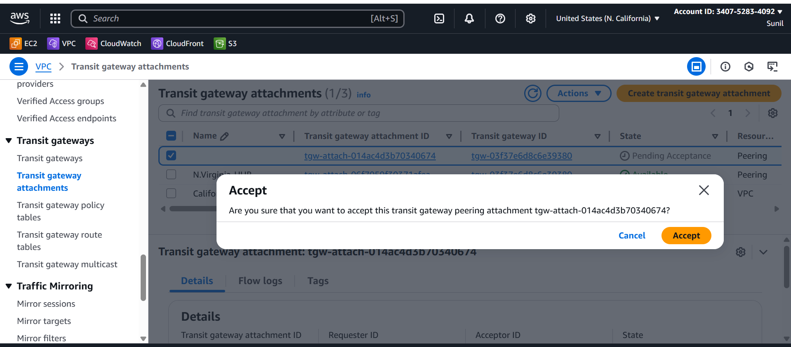

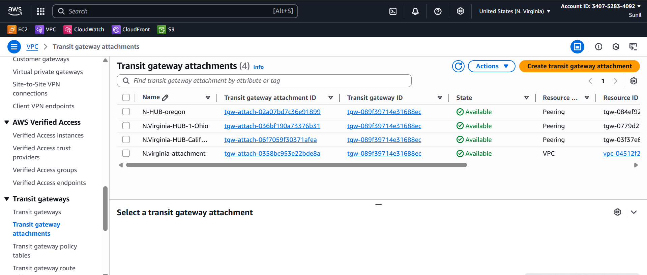

**Step-6:**

**Configure TGW Route Tables**

* After the peering is active, you must **update TGW route tables** so traffic can flow.

1. In each TGW’s **Route Table**, add routes for the remote VPC CIDRs.

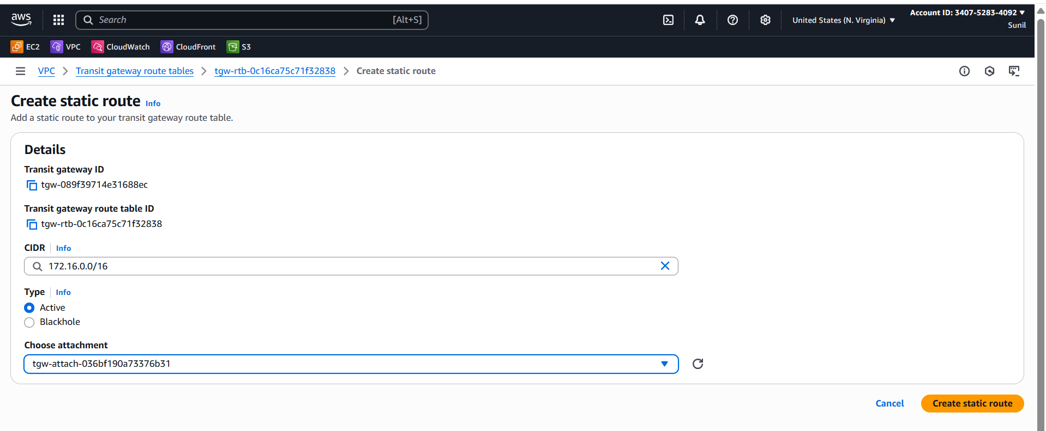

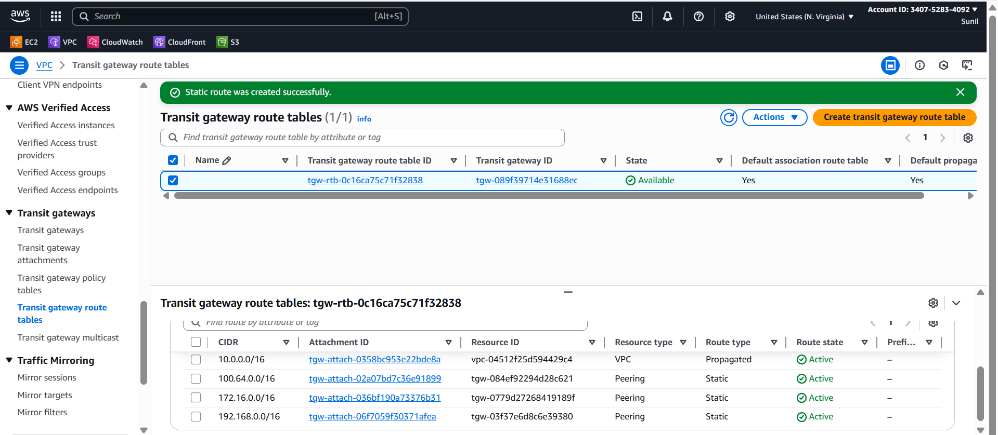

**Step -7 Update VPC Route Tables in all regions**

For each **VPC’s private subnet RTB**:

Add a route to the **other VPC CIDRs via TGW attachment**.

Repeat in all the other Regions

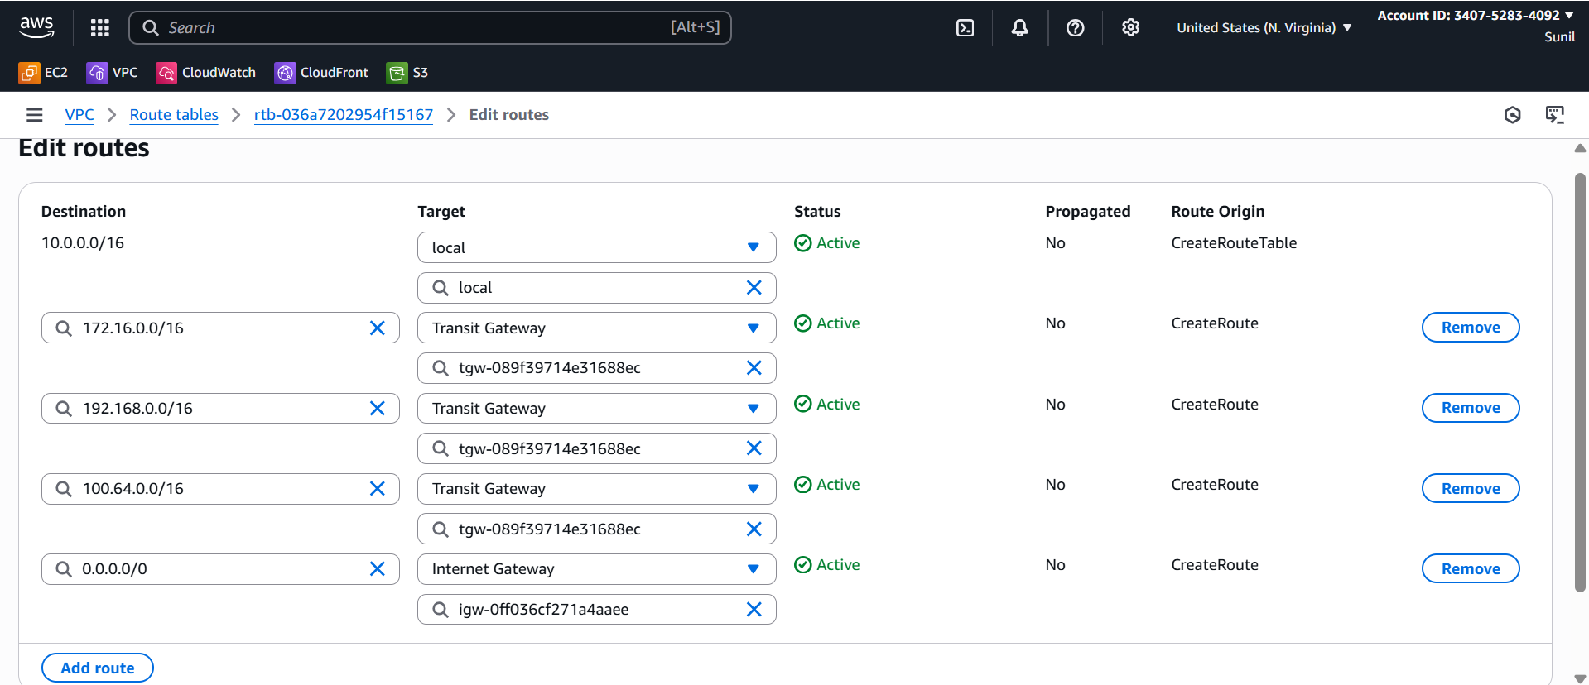

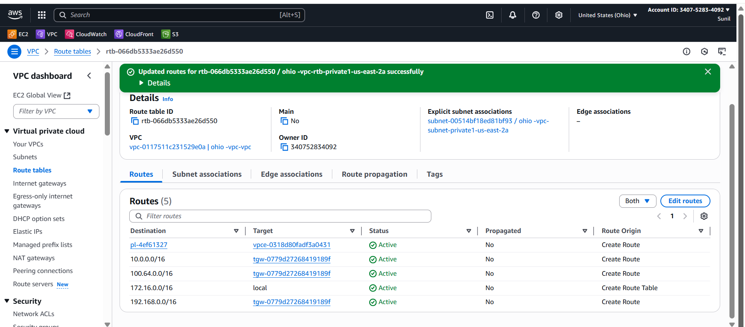

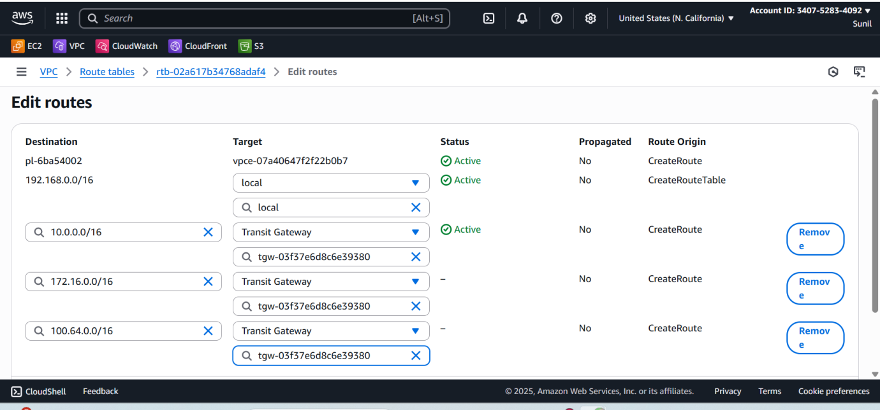

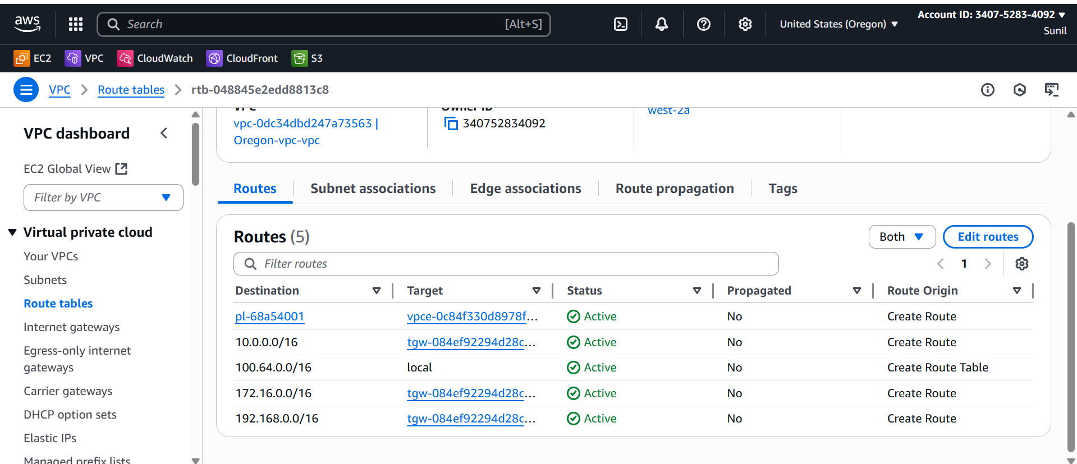s

**Step-8 :Verification**

**EC2-to-EC2 connectivity:**

* **Launch 1 EC2 in each VPC in public subnet- - Vpc-1-( N.Virginia)**

**Remaining all Launch 1 EC2 in each VPC private subnet.**

* **From Virginia EC2 → ping Ohio EC2’s private IP.**

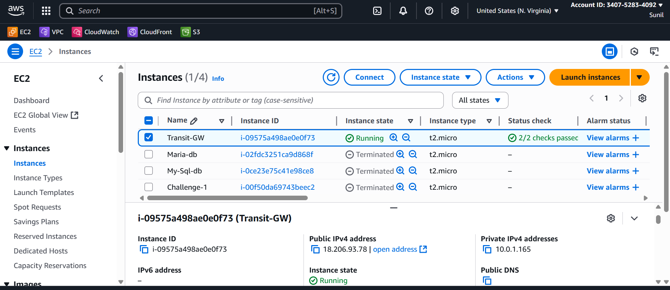

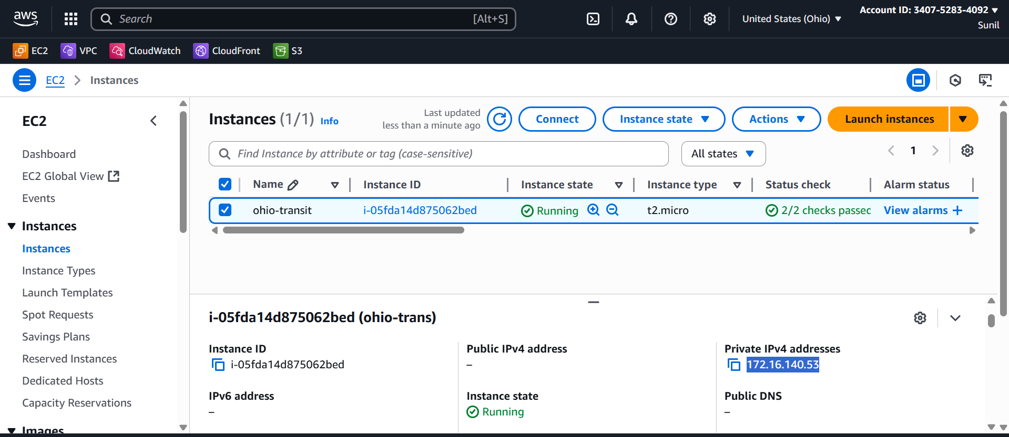

**Virginia EC2 → ping Ohio EC2’s private IP.**

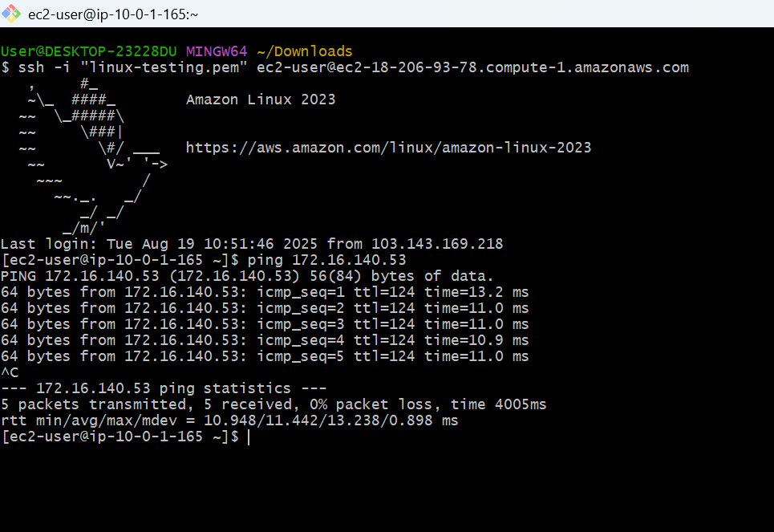

**Virginia EC2 → ping California EC2’s private IP.**

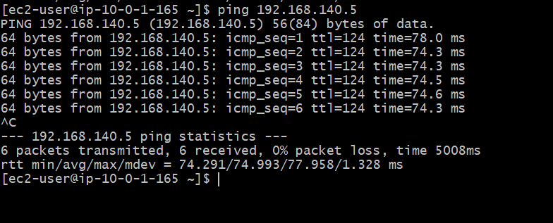

Using the Jump server

From virgina ec2 to ohio ec2

Cat the ohio pem key and give the permissios and login into ohio using privateip

*root@ip-10-0-1-165 ~]# ssh -i ohio.pem ec2-user@172.16.140.53*

after login into ohio

Check the ping from Ohio to N.virginia

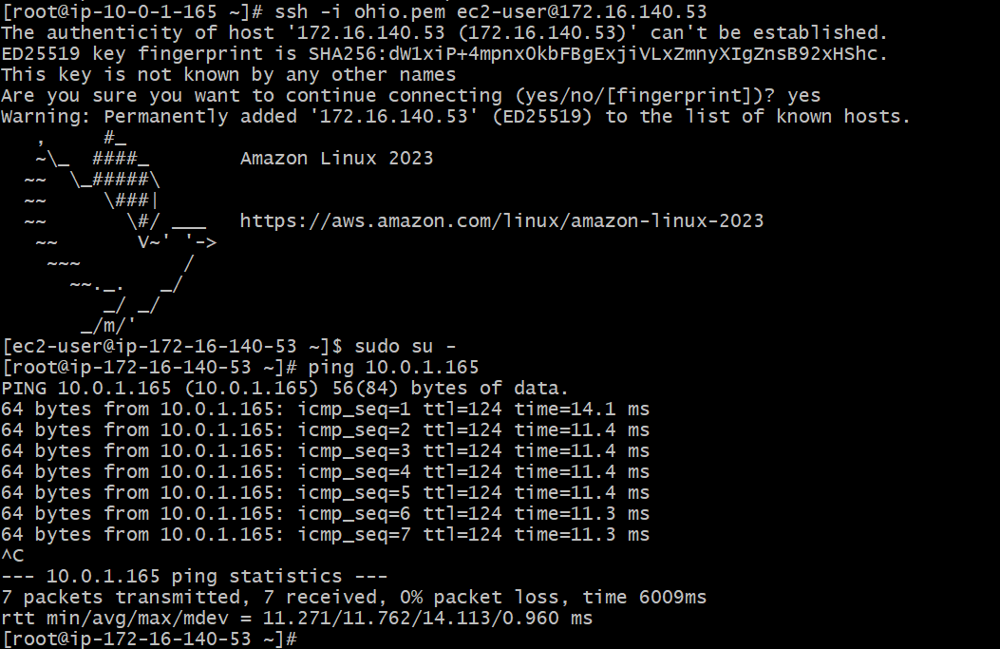

**From Ohio to California**

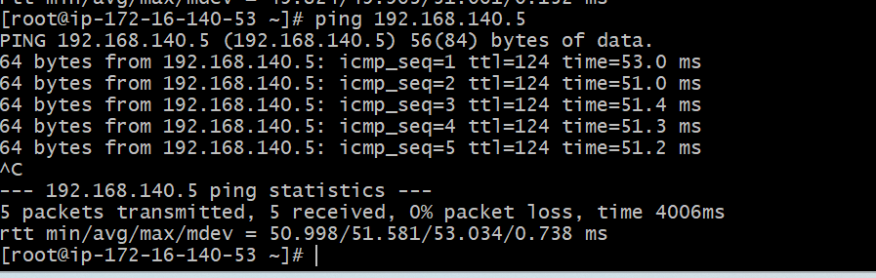

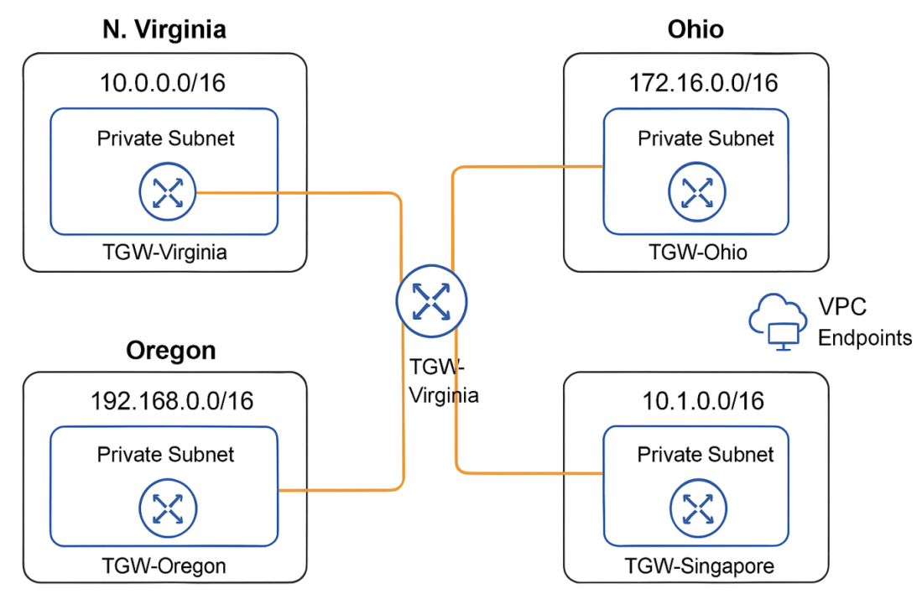

1. **Configure VPC endpoints to securely access AWS services without internet gateways or NAT gateways, ensuring data privacy and minimizing exposure to external threats.**

**Configure VPC Endpoints (Private access to AWS services)**

For **each VPC** → Go to **Endpoints → Create Endpoint**.

Choose services:

* Gateway Endpoint: **S3**

Create an S3 endpoint in Ohio

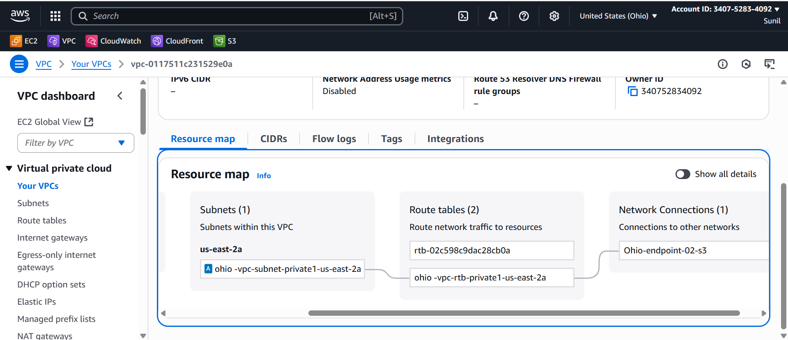

From N.virgina Ec2­--🡪ssh to Ohio private ip

Login to ohio ec2 and configure aws   
and check the access to resources like s3

aws s3 ls --region us-east-2



Create an S3 endpoint California and connect with Ssh private ip in ohio

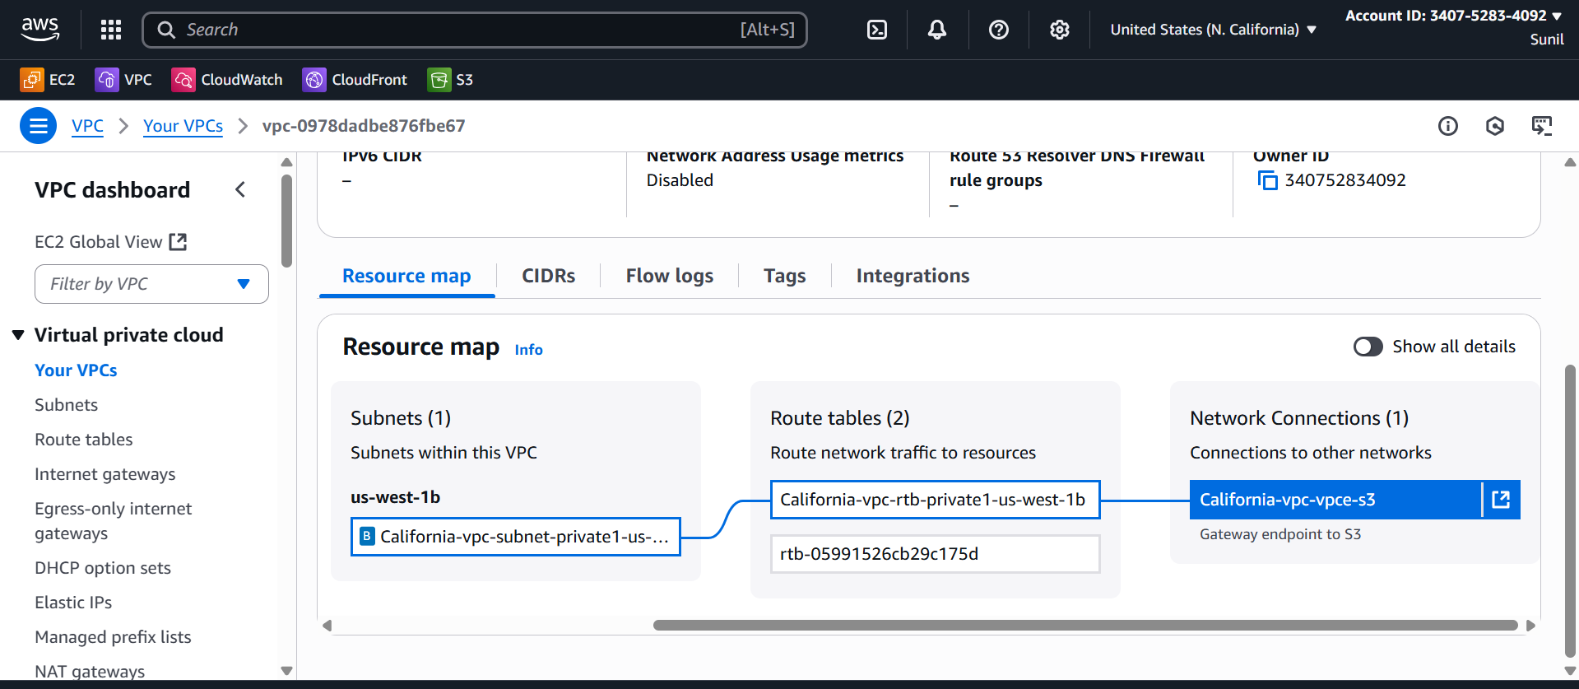

From Ohio -🡪jump into California ec2 private ip

And give permissions

And configure aws in this region

Create a s3 bucket in California region

Verify using

aws s3 ls --region us-west-1

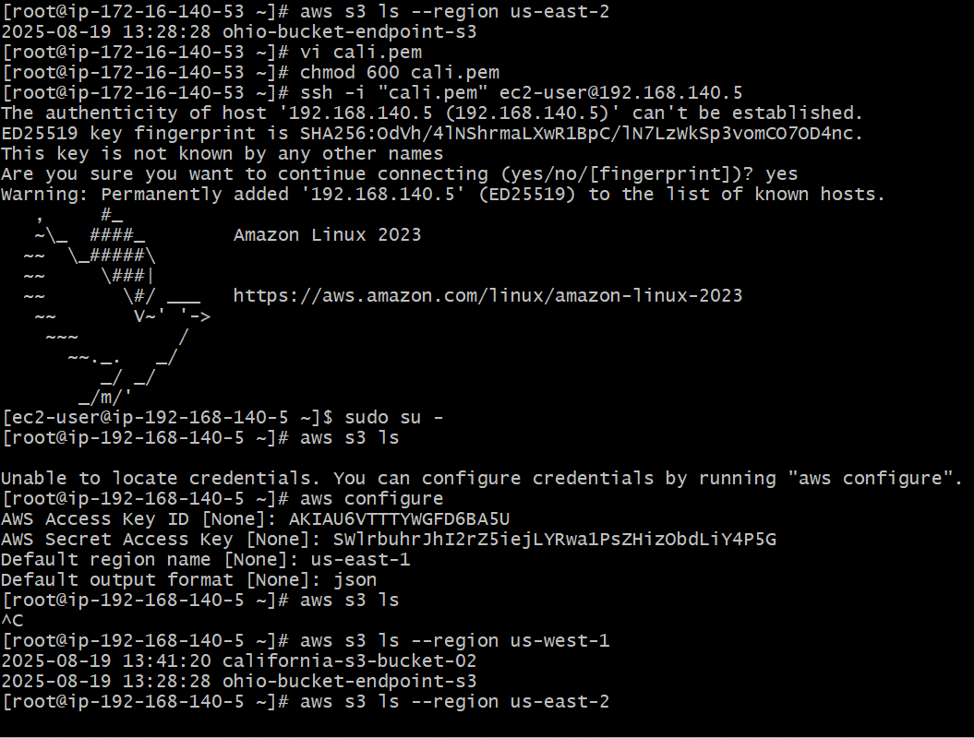

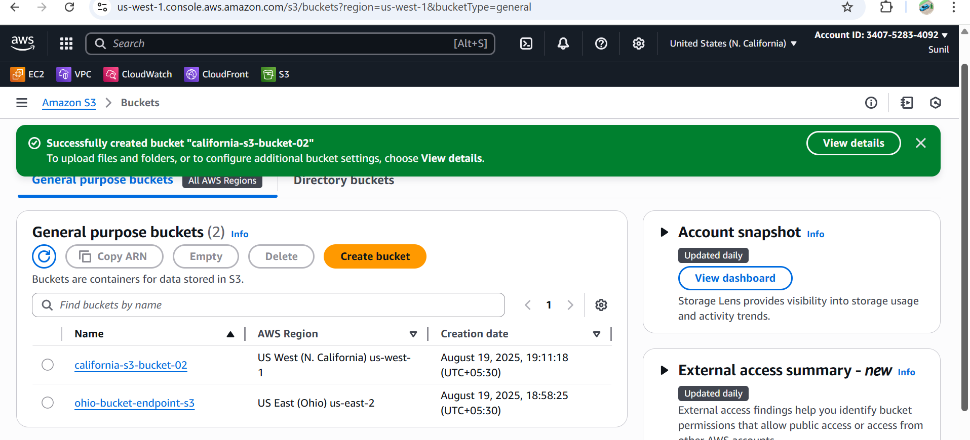

Simlarly Configure in Other regions and Verify